EXPERIMENT NO-1(A)
MATPLOTLIB LIBRARY-DATA VISUALLIZATION

Aim:
To analyze the trends of data science job posting over the last decade

Procedure:
- Import NumPy and Matplotlib
- Give some dummy data and make it as Data Frame
- Use Bar plot for year over pasting
- Give attributes like xlabels ,ylabel, title etc
- Finally show line plot

Program:
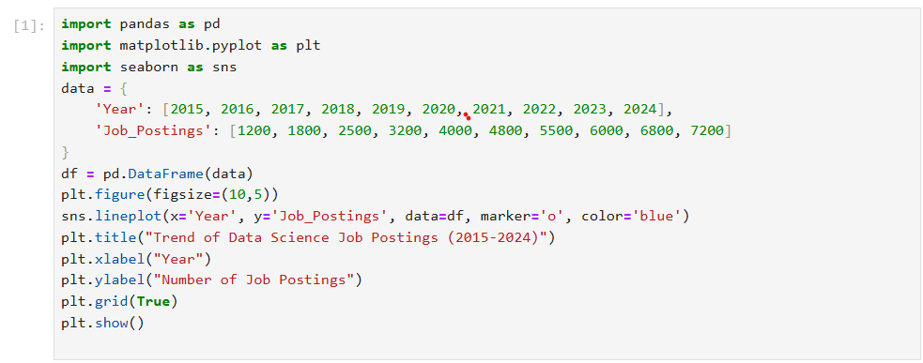
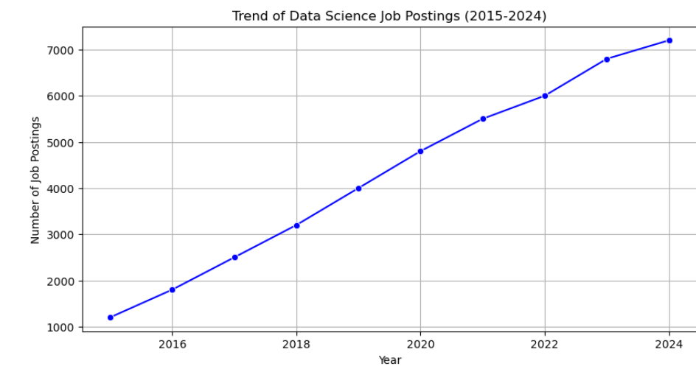
Result:
Thus the python program to visualize data using line plot is executed successfully

EXPERIMENT NO-1(B)
MATPLOTLIB LIBRARY-DATA VISUALLIZATION

Aim:
To analyze and visualize distribution of various of Data Science

Procedure:
- Import pandas and Matplotlib
- Create a dataset
- Visualize through pie chart for job posting for various Data Science Roles
- Use some attributes like colors,title,figure size etc
Program:

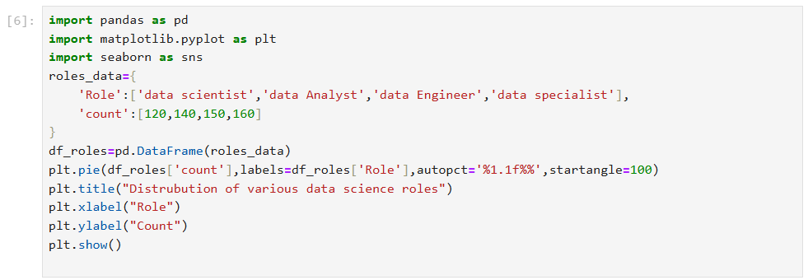
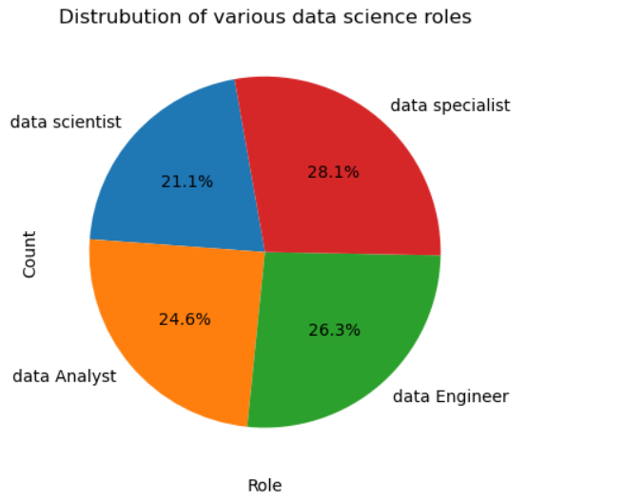
Result:
Thus the python program to visualize data science roles using line plot is executed successfully

EXPERIMENT NO-1(C)
DISPLAY THE STRUCTURED, UNSTRUCTURED AND SEMI-STRUCTURED DATA

Aim:
To differentiate structured, unstructured and semi structured data.

Procedure:
- Import Matplotlib and Pandas Create a Data Frame for structured data and print it.
- Likewise create Data Frame for unstructured and normalize.
- It using attribute and print it
- Now create unstructured data and print it

Program:
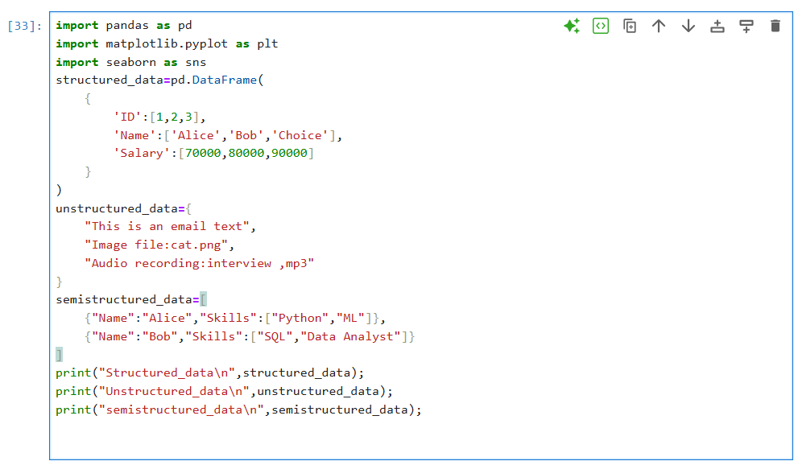

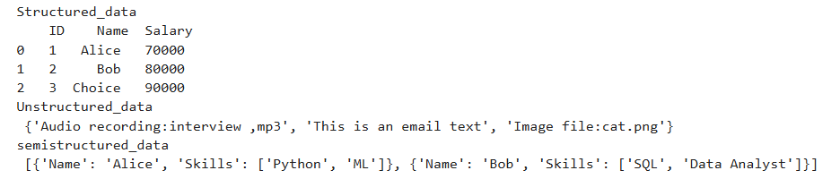

Result:
Thus the python program of the structured, unstructured and semi-structured data executed successfully.

EXPERIMENT NO-1(D)
Study of Encrypt and decrypt sensitive data

Aim:
To study the Encrypt and decrypt sensitive data.

Procedure:
- Import pandas Data Frame with rows and columns.
- using JSON, dictionaries, or lists without a fixed schema.
- free text, images, or multimedia.
- formats, storage methods, and analysis ease.
- Structured → easy tantalize, Semi-structured → flexible, Unstructured → needs preprocessing.

Program:
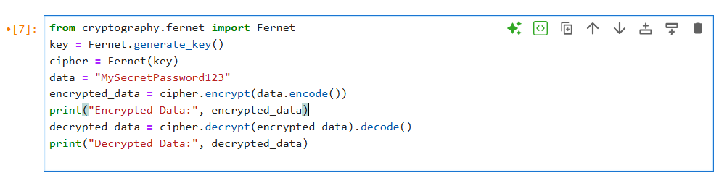

Result:
Thus the python program of the Encrypt and Decrypt sensitive data executed successfully.

